**Specification of Software Requirements**

**Project: Qualification management system for the Unidad Educativa Mahanaym**

**Document sheet**

| **Date** | **Revisión** | **Author** |
| --- | --- | --- |
| 10/11/2024 | 1 | Yeshua Chiliquinga  Alejandro Cuadrado  Isaac Escobar |

Document validated by the parties on:

| The NRC of | For the university |
| --- | --- |
| Advanced Web Programming | Universidad de las Fuerzas Armadas ESPE |

**1. Introduction 4**

1.1 Purpose 4

1.2 Reach 4

1.3 Personnel involved 4

1.4 Definitions, acronyms and abbreviations 5

1.5 References 5

1.6 Summary 6

**2 General Description 6**

2.1 Product perspective 6

2.2 Product functionality 6

2.3 User characteristics 7

2.4 Restrictions 8

2.5 Assumptions and dependencies 8

**3 Specific requirements 8**

3.1 Common requirements for interfaces 14

3.1.1 User interfaces 14

3.1.2 Hardware interfaces 14

3.1.3 Software interfaces 14

3.1.4 Communication interfaces 14

# **Introduction**

Currently, the management of grades in educational institutions faces several challenges, especially in the Mahanaym Educational Unit. Despite having a grading platform, it is not fully adapted to the constant updates of educational guidelines and the institution's customization needs. This situation hinders real-time academic tracking and complicates the efficient administration of grades.

This software requirements specification document details the development of a grade management system designed specifically to meet the needs of the Mahanaim Educational Unit. The objective of the system is to allow the recording, updating and consultation of grades, ensuring the integrity of the information and facilitating access to teachers, students and parents. Through this system, we seek to optimize the academic organization of the institution, adapting to ministerial guidelines and offering a secure and flexible tool to improve the grading and reporting process.

## **1.1 Purpose**

The grade management system will provide a centralized platform for the administration of grades, in which students' academic results can be registered, updated and consulted. The system will include security functionalities, access control, report generation and the ability to customize the configuration of percentages and types of evaluations according to Ministry of Education guidelines.

## **1.2 Reach**

This requirements specification is addressed to the user of the system, to continue with the development of educational applications on the institution and to deepen the automation of this, which has as its main objective to manage the various administrative processes (Inventory, Events, Course, and Information) and academic (Virtual Classroom).

## **1.3 Personnel involved**

| **Name** | Yeshua Chiliquinga |
| --- | --- |
| **Rol** | Analyst, designer, and programmer |
| **Professional Category** | Junior Programmer, Student |
| **Responsibility** | SIS-I data analysis, design, and programming |
| **Contact Information** | [yachiliquinga1@espe.edu.ec](mailto:yachiliquinga1@espe.edu.ec) |

| **Name** | Alejandro Cuadrado |
| --- | --- |
| **Rol** | Analyst, designer, and programmer |
| **Professional Category** | Junior Programmer, Student |
| **Responsibility** | SIS-I data analysis, design, and programming |
| **Contact Information** | [jacuadrado1@espe.edu.ec](mailto:jacuadrado1@espe.edu.ec) |

| **Name** | Isaac Escobar |
| --- | --- |
| **Rol** | Analyst, designer, and programmer |
| **Professional Category** | Junior Programmer, Student |
| **Responsibility** | SIS-I data analysis, design, and programming |
| **Contact Information** | [iaescobar3@espe.edu.ec](mailto:iaescobar3@espe.edu.ec) |

## **1.4 Definitions, acronyms and abbreviations**

| ***Name*** | ***Description*** |
| --- | --- |
| **Qualification Management System** | A platform for the registration and tracking of qualifications. |
| **Ministry of Education** | A government entity that regulates educational guidelines. |
| **User** | The person with access to the system, such as students, parents, and teachers. |

## **1.5 References**

| **Document Title** | **Reference** |
| --- | --- |
| Standard IEEE 830 - 1998 | IEEE |
| Interview with the rector of the Mahanaym Educational Unit. | Video Link: <https://www.youtube.com/watch?v=p--gCIvxF68> |

## **1.6 Summary**

This document presents the requirements specification for the development of a grade management system for the Mahanaym Educational Unit. Based on the problems and needs identified, the proposed system will facilitate the recording, updating, and consultation of academic grades in real time. In addition to improving access to information for students and parents, the system will allow advanced customization in the configuration of evaluations, according to the standards and guidelines of the Ministry of Education.

Throughout the document, functional and non-functional requirements are detailed, and structured according to the IEEE 830 standard, to ensure that the system meets the objectives of security, accessibility, and efficiency. The purpose of this project is to provide the institution with an integral platform that centralizes and speeds up the evaluation process, improving the quality of academic monitoring.

# **2 General Description**

## **2.1 Product perspective**

The grade management system will be integrated into the educational environment of the Mahanaym educational unit and will be designed to be accessible from any device with an Internet connection. The platform will allow users to access information quickly and securely.

## **2.2 Product functionality**

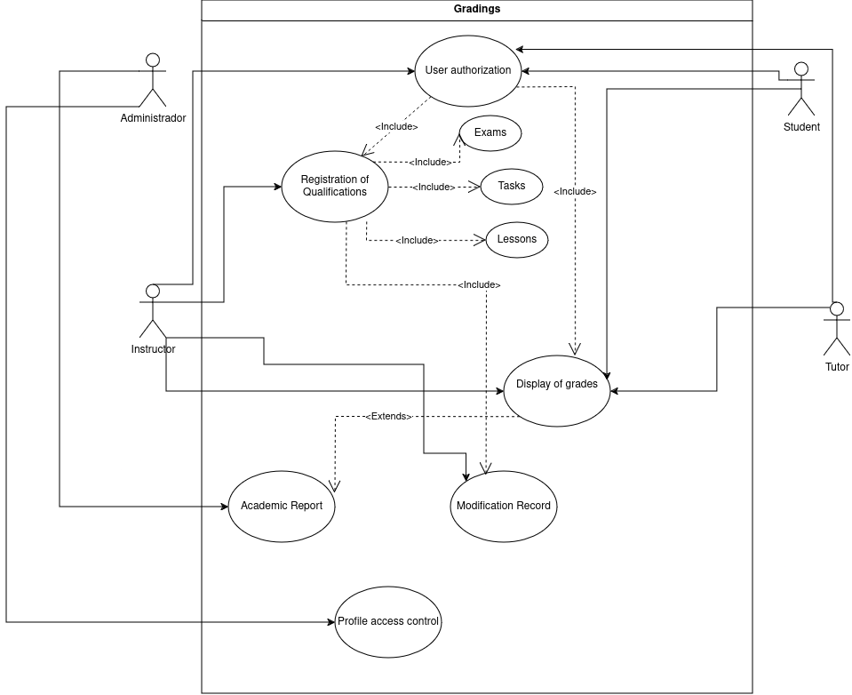

## **2.3 User characteristics**

| **User type** | Administrator |
| --- | --- |
| **Formation** | TSU in Computer Science |
| **Activities** | Administrator |

| **User type** | Teacher |
| --- | --- |
| **Formation** | Educator |
| **Activities** | Facilitate the learning process and manage your student's grades. |

| **User type** | Students |
| --- | --- |
| **Formation** | Initial, Basic General, and Baccalaureate |
| **Activities** | They will have access to consult grades and be evaluated on the platform |

| **User type** | Parents or Guardians |
| --- | --- |
| **Formation** | Responsible for students at home |
| **Activities** | They will have access to consult the qualifications. |

## **2.4 Restrictions**

· Interface to be used with the Internet.

- Domain Usage (X)

- Languages and technologies in use: HTML, CSS, NODE JS.

- Servers must be able to handle queries concurrently.

- The system shall be designed according to a client/server model.

- The system shall have a simple design and implementation, independent of platform or programming language.

- The system must comply with Ministry of Education guidelines regarding types of assessments and percentages.

## **2.5 Assumptions and Dependencies**

- The requirements described here are assumed to be stable.

- The equipment on which the system is to be run must meet the above requirements to ensure proper execution of the system.

# **3 Specific requirements**

**Functional Requirements**

| **Identification of the requirement:** | RF01 |
| --- | --- |
| **Name of Requirement:** | User Authentication. |
| **Characteristics:** | Users must identify themselves to access any part of the system. |
| **Description of the requirement:** | The system shall allow the recording of grades for different types of assessments, such as exams, assignments and projects. |
| **NON-functional requirement:** | · RNF01, RNF02, RNF05 |
| **Priority of the requirement:**  High | |

| **Identification of the requirement:** | RF02 |
| --- | --- |
| **Name of Requirement:** | Viewing Notes |
| **Characteristics:** | Authorized users must be able to view grades and academic progress. |
| **Description of the requirement:** | The system will allow students and parents to view grades for each subject, as well as a summary of academic performance through a grade query module. Teachers will be able to view aggregate statistics for their classes. |
| **NON-functional requirement:** | · RNF01, RNF02, RNF05 |
| **Priority of the requirement:**  High | |

| **Identification of the requirement:** | RF03 |
| --- | --- |
| **Name of Requirement:** | Record of Qualifications |
| **Characteristics:** | Teachers will be able to record grades according to the types of evaluations established. |
| **Description of the requirement:** | The system will allow teachers to record student grades, assigning a specific value to each type of evaluation (exams, homework, lessons) according to previously defined percentages. Each record will include the date, type of evaluation, and additional comments. |
| **NON-functional requirement:** | · RNF01  · RNF02 |
| **Priority of the requirement:**  High | |

| **Identification of the requirement:** | RF04 |
| --- | --- |
| **Name of Requirement:** | Academic Report |
| **Characteristics:** | Generation of report cards and performance reports. |
| **Description of the requirement:** | The system shall generate academic reports showing overall student performance, allowing teachers and authorities to view grade point averages by subject, course or student. Parents will be able to access detailed reports for each trimester. |
| **NON-functional requirement:** | · RNF01, RNF02, RNF05 |
| **Priority of the requirement:**  High | |

| **Identification of the requirement:** | RF05 |
| --- | --- |
| **Name of Requirement:** | Record of Modifications |
| **Characteristics:** | Record of all changes made to the appraisal system. |
| **Description of the requirement:** | The system must store the date, time, user, and details of each modification made to grades to maintain a history of changes, ensuring transparency and security in the handling of grades. |
| **NON-functional requirement:** | · RNF01, RNF02 |
| **Priority of the requirement:**  High | |

| **Identification of the requirement:** | RF06 |
| --- | --- |
| **Name of Requirement:** | Access Control by Profile |
| **Characteristics:** | Users will only be able to access authorized sections according to their profile. |
| **Description of the requirement:** | The system must assign specific permissions to each profile (teacher, student, parent, administrator), limiting access to the corresponding modules according to their role. This includes the restriction of viewing and modifying grades and reports. |
| **NON-functional requirement:** | · RNF01, RNF02 |
| **Priority of the requirement:**  High | |

**Non-functional requirements.**

| **Identification of the requirement:** | RNF01 |
| --- | --- |
| **Name of Requirement:** | System interface. |
| **Characteristics:** | The system must be available 24 hours a day, allowing access from any device with an Internet connection. |
| **Description of the requirement:** | The system must have an intuitive and simple user interface. |
| **Priority of the requirement:**  High | |

| **Identification of the requirement:** | RNF02 |
| --- | --- |
| **Name of Requirement:** | Help in the use of the system. |
| **Characteristics:** | The system shall have user authentication and access logging to ensure data security. |
| **Description of the requirement:** | The interface must be complemented by a good help system (the administration may fall to personnel with little experience in the use of computer applications). |
| **Priority of the requirement:**  High | |

| **Identification of the requirement:** | RNF03 |
| --- | --- |
| **Name of Requirement:** | Maintenance. |
| **Characteristics:** | The system shall comply with a response time of less than 3 seconds for loading information on the screen. |
| **Description of the requirement:** | The system must have easily updatable documentation that allows maintenance operations to be carried out with the least possible effort. |
| **Priority of the requirement:**  High | |

| **Identification of the requirement:** | RNF04 |
| --- | --- |
| **Name of Requirement:** | Design of the interface to the web feature. |
| **Characteristics:** | The system must be scalable to support an increase in the number of users without affecting performance. |
| **Description of the requirement:** | The user interface must conform to the characteristics of the institution's website, within which the process management system and the inventory will be incorporated. |
| **Priority of the requirement:**  High | |

| **Identification of the requirement:** | RNF05 |
| --- | --- |
| **Name of Requirement:** | Performance |
| **Characteristics:** | The system will guarantee users a performance in terms of the data stored in the system, offering reliability to the system. |
| **Description of the requirement:** | Guarantee the performance of the computer system to the different users. In this sense, the information stored or records made may be consulted and updated permanently and simultaneously, without affecting the response time. |
| **Priority of the requirement:**  High | |

| **Identification of the requirement:** | RNF06 |
| --- | --- |
| **Name of Requirement:** | User Level |
| **Characteristics:** | It will guarantee the user access to information according to the level he/she has. |
| **Description of the requirement:** | Facilities and controls to allow access to information to authorized personnel through the Internet, to consult and upload relevant information for each of them. |
| **Priority of the requirement:**  High | |

| **Identification of the requirement:** | RNF07 |
| --- | --- |
| **Name of Requirement:** | Continued system reliability. |
| **Characteristics:** | The system will have to be operational 24 hours a day, 7 days a week. Since it is a web page designed for data upload and communication between users. |
| **Description of the requirement:** | The availability of the system must be continuous with a service level for the users of 7 days per 24 hours, guaranteeing an adequate scheme that allows the possible failure in any of its components, to count on a contingency, generation of alarms. |
| **Priority of the requirement:**  High | |

| **Identification of the requirement:** | RNF08 |
| --- | --- |
| **Name of Requirement:** | Information security |
| **Characteristics:** | The system will guarantee users security in terms of the information that is processed in the system. |
| **Description of the requirement:** | Ensure the security of the system with respect to the information and data handled such as documents, files and passwords. |
| **Priority of the requirement:**  High | |

## **3.1 Common requirements for interfaces**

### **3.1.1 User interfaces**

The user interface will consist of a set of windows with buttons, lists, and text fields. It shall be built specifically for the proposed system and shall be visualized from a web browser.

### **3.1.2 Hardware interfaces**

It will be necessary to have computer equipment in perfect condition with the following characteristics:

- Network adapters.

- 1.66GHz processor or higher.

- Minimum memory of 256Mb.

- Mouse.

- Keyboard.

### **3.1.3 Software interfaces**

- Operating System: Windows XP or higher, Linux.

- Browser: Mozilla or Chrome.

### **3.1.4 Communication interfaces**

Servers, clients, and applications communicate with each other using standard Internet protocols whenever possible. For example, existing protocols (FTP or other convenient protocols) should be used to transfer files or documents.

